COMP7250 Course Project

21442185

Wang Yuhui

INTRODUCTION

Data augmentation is one of method to reduce the model’s overfitting problems in machine learning task. In the procedure of training the machine learning model. The small size dataset could have the overfitting problem, the training accuracy for the model can reach a high performance but the testing dataset may have a very low result. This project applied several methods and adjusted the parameters to enhance the model capacity and reduce the overfitting problem in image classification task.

PROBLEM DEFINITION

Data augmentation applied for image classification task. In this project the dataset choose from Kaggle DOGs VS CATs dataset. The link of dataset is below.

<https://www.kaggle.com/competitions/dogs-vs-cats/data>

The dataset contains 25000 images. 12500 images for cats, the remain 12500 for dogs. Due to limitation of hardware, 5000 images are randomly selected. 4000 images for training and 1000 images for testing. For the data augmentation, 5 methods are applied Flip, Zoom, Rotation, Crop, and Gaussian Noise. The project will test the testing performance of different augmentation methods and if the combination of different methods can reach further enhancement.

METHODOLOGY

1. Preprocessing

The first part of training the model. Import pathlib library to get the images in the folder. Split the image path to cat and dog list

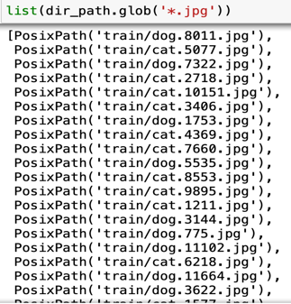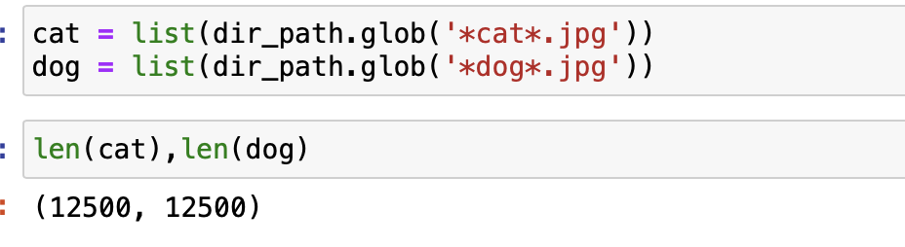

Import the PIL library. Check the image and image size of the images

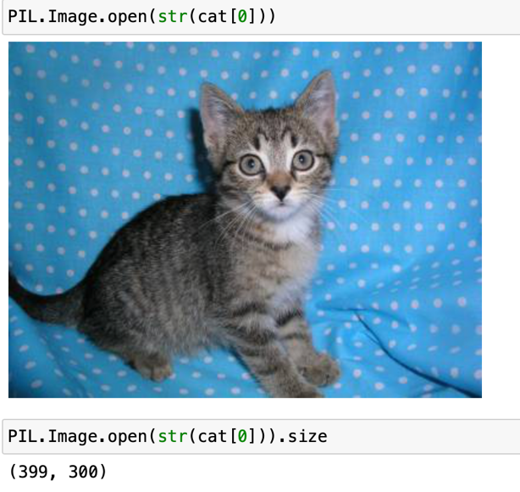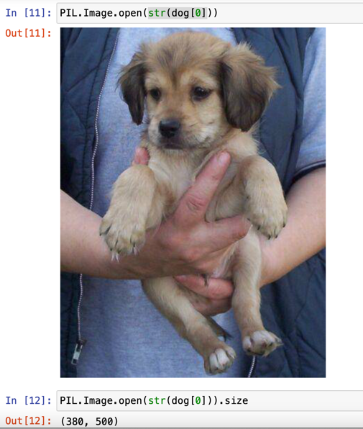

For all images, the size should be same, use the PIL resize function to resize the images

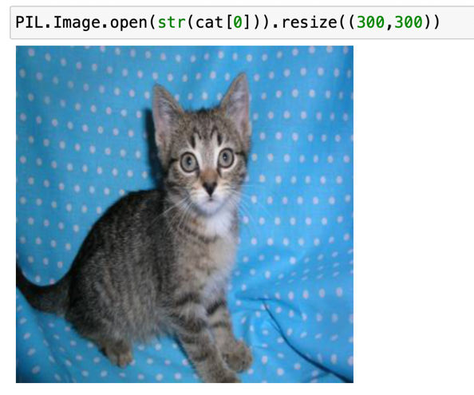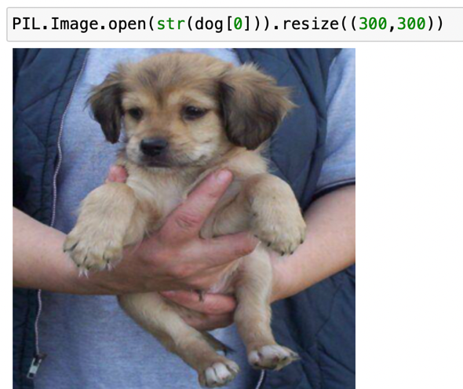

Resize all images to the shape (300,300) and append the images to list X, append the image labels to list y.

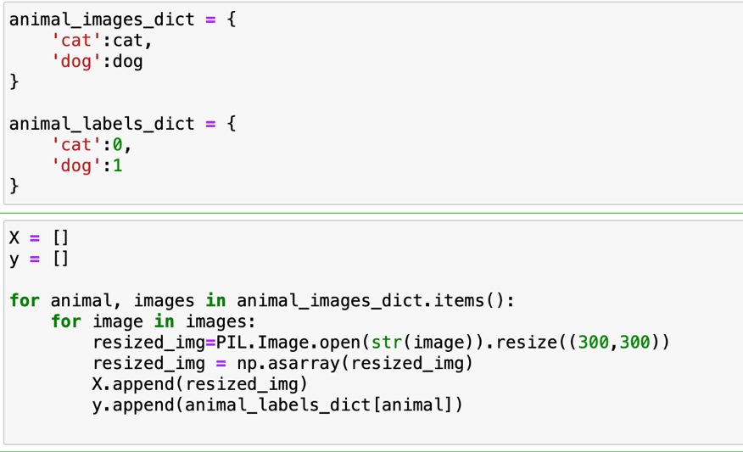

Set the shuffle to Ture for randomly split the data to training data and testing data, the default split percentage is 0.8 for training data and 0.2 for testing data. Because it’s randomly split, so select first 4000 images in training data, and first 1000 in testing data. Divided the data by 255 to normalized the data between 0 and 1.

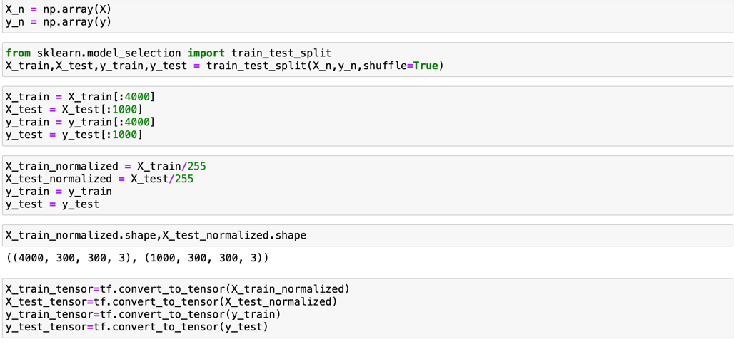

1. Training model

The structure of the model have 3 convolutional layers, the first layers input shape is 3 and the output shape is 16,the image shape is (300,300), the pool size is using the default 2 by 2, after first maxpooling layer,the size change to (16,150,150). The same as before, the shape of the image change to (32,75,75) after the second maxpooling layer, and (64,37,37) after the third maxpooling layer. Use Flatten() function to convert to 1d array.

Put it into the hidden layer with 512 neurons, change the last neuron’s activation function. The output can be the probability of the outcome 0 or 1.

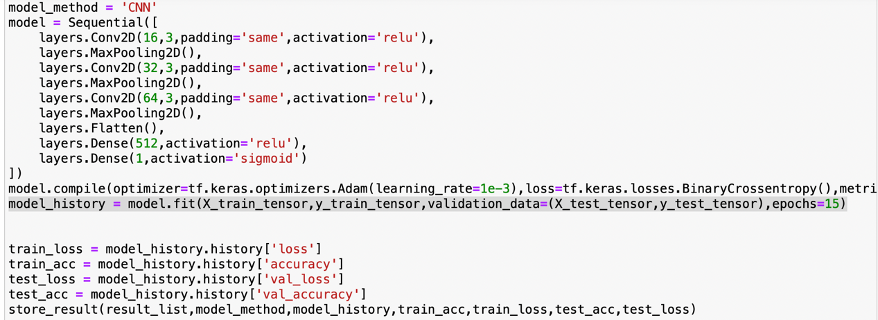

Define the optimizer Adam and set the learning rate 0.001, because it’s a binary classification problem, use Binary Cross Entropy as the loss function.

After fit the training data. Can use model.prediction() function to predict the input data. It will return the probability of 0 or 1, use np.round() function to check the last outcome.

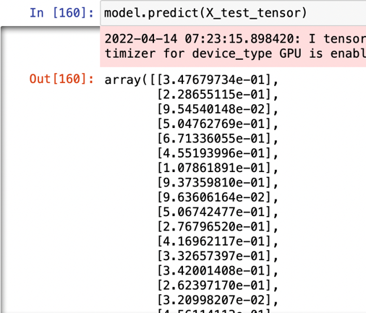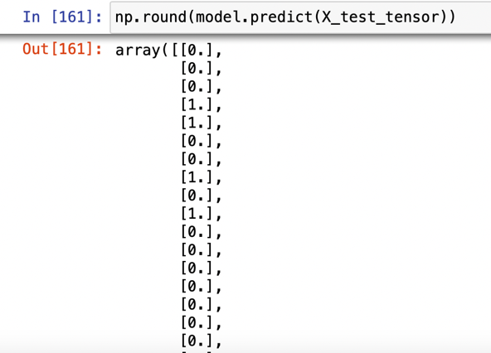

After the first training the result of the training accuracy is 1, but the testing accuracy is 68.5%. The model is obviously overfitting.



To reduce the overfitting problem. Different data augmentation methods are applied.

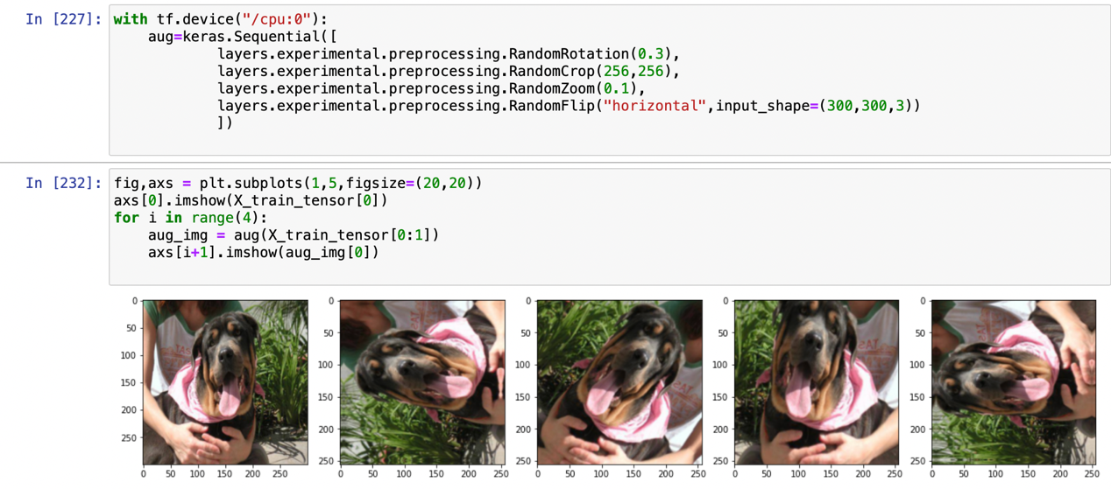

A function is defined at the beginning to save the training data. Include the augmentation method, training model, accuracy and loss for training data and testing data.

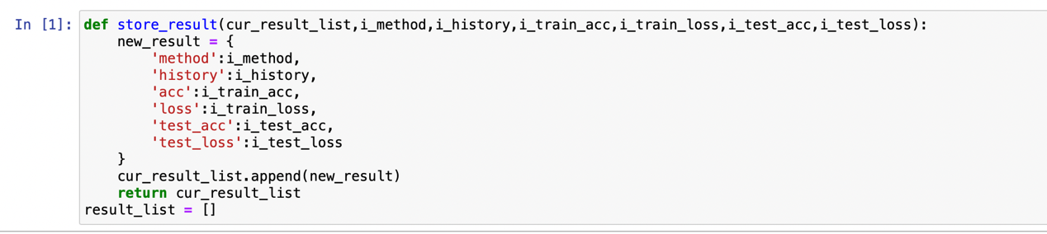

RESULT

The test use 5 methods for data augmentation, Flip, Zoom, Rotation, Crop, Gaussian Noise. Each method adopts 3 different parameters for training, after all training, integrate the first 3 highest method together to train the model and check the performance of these models.

1. Normal CNN Training



The training loss is very low, the training accuracy is 1. But the testing accuracy only have 0.6850.

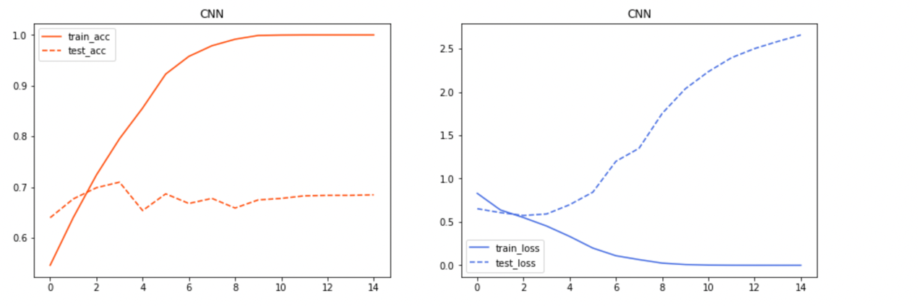

1. Flip
2. Random Horizontal Flip



The training loss is low, and high training accuracy. The testing data’s accuracy increased to 0.7600.

1. Random Vertical Flip



Same as before, low loss and high accuracy on training data, testing accuracy 0.7020 become a bit lower than horizontal flip.

1. Random Horizontal and Vertical Flip



The training accuracy is lower than another two flip method which is 0.9313, the testing accuracy is 0.7230.

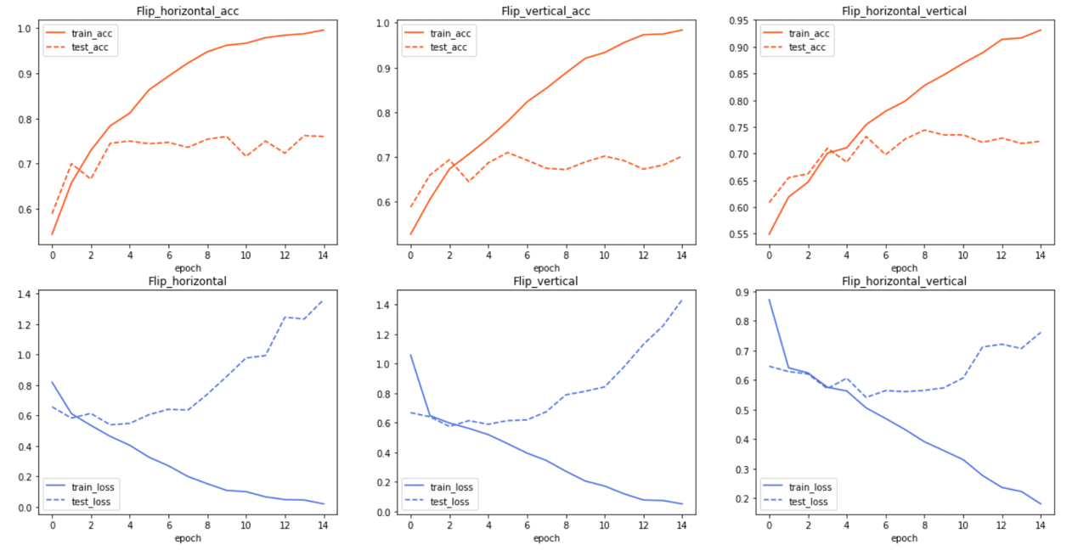

1. Zoom
2. Random Zoom in 10 percent



The training accuracy is 0.9798 and testing accuracy is 0.7360.

1. Random Zoom in 20 percent



Training accuracy decreased a little compare with zoom in 10%, the testing accuracy increased to 0.7670

1. Random Zoom in 30 percent



The result seems the best performance, testing accuracy is 0.7870. Only 10% between training and testing accuracy.

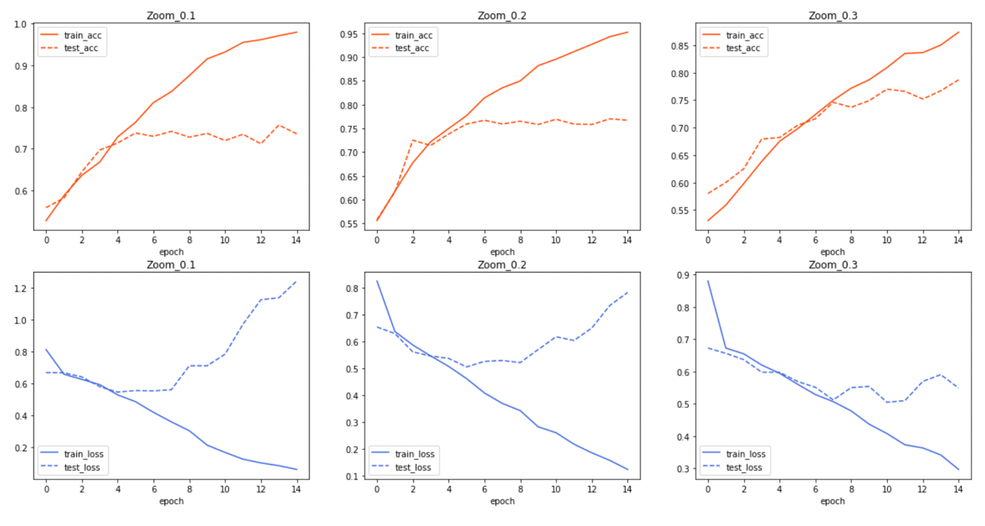

1. Rotation
2. Random Rotate in 10 percent



The result seems similar with Zoom in 30%, which training accuracy is 0.8523 and test accuracy is 0.7700.

1. Random Rotate in 20 percent



The training and testing accuracy is close, only 5%. But the accuracy is lower, which is 0.7640 and 0.7180.

1. Random Rotate in 30 percent



Similar with the last result.

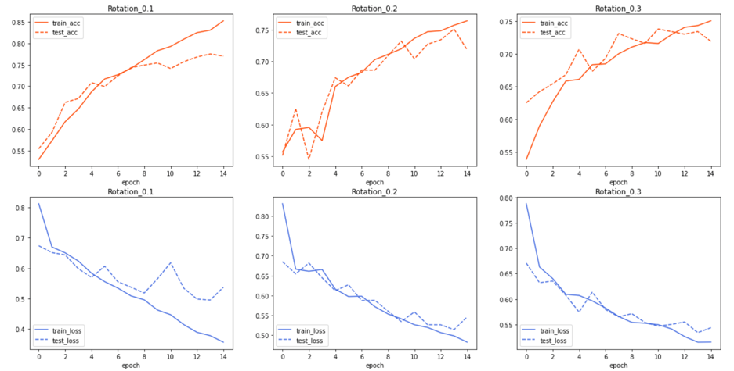

1. Crop
2. Random crop the image to 256\*256



Training accuracy is 0.8448, testing accuracy is 0.7850. This method improved the model capacity.

1. Random crop the image to 192\*192



The training and testing accuracy trend to get close but decrease to 0.7425 and 0.7190.

1. Random crop the image to 128\*128



The testing accuracy getting very low, 0.6120.

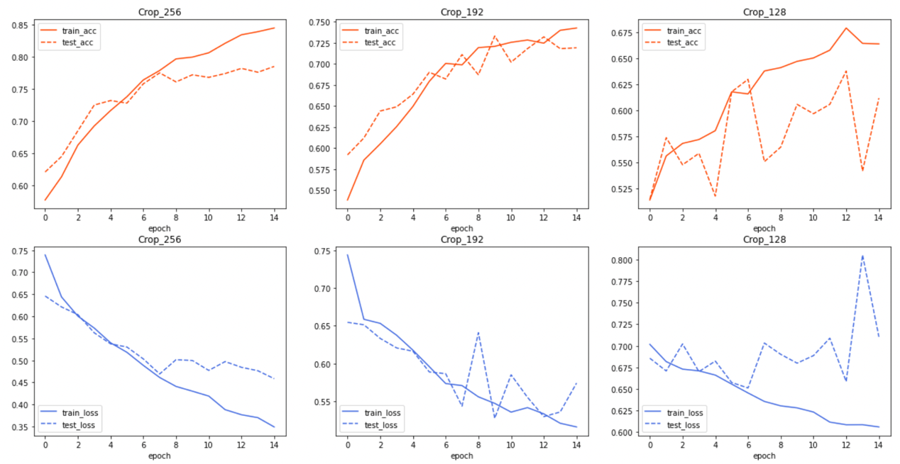

1. Gaussian Noise

The standard deviation is set as 0.1, 0.2, 0.3 respectively. The performance appears not good on gaussian noise.







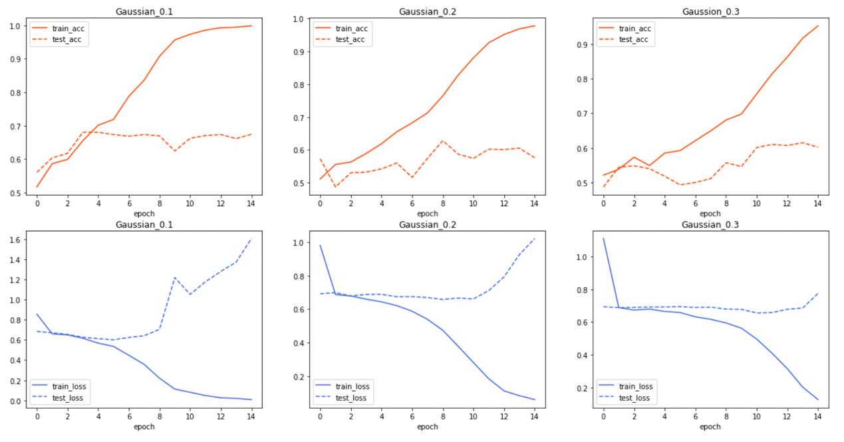

1. Combination of the 3 top augmentation method

This method takes the 3 best augmentation method from above, which is random zoom in 30%, random rotation 10%, random crop to size 256\*256. The model also takes a 20 percent drop out layer to reduce the redundancy for a better generalization.

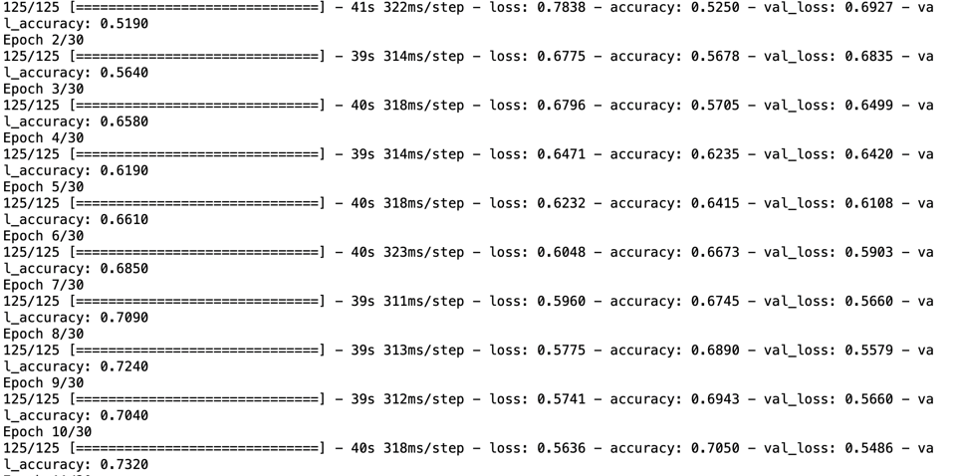

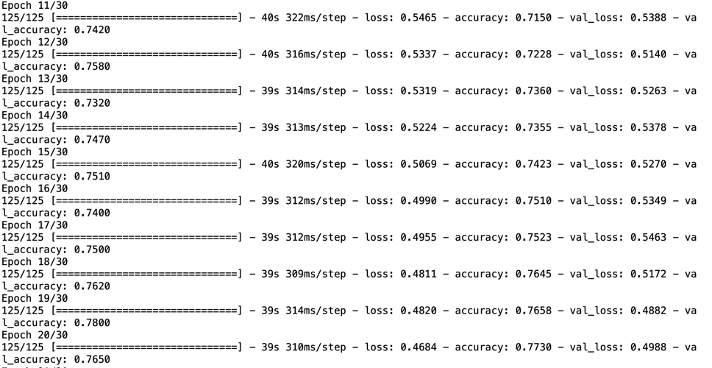

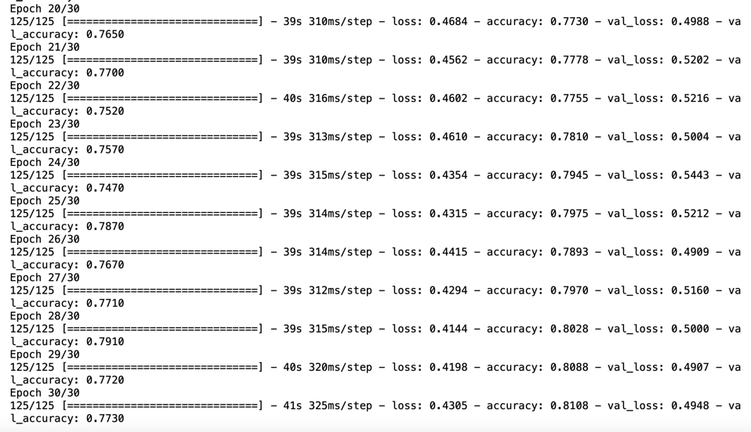

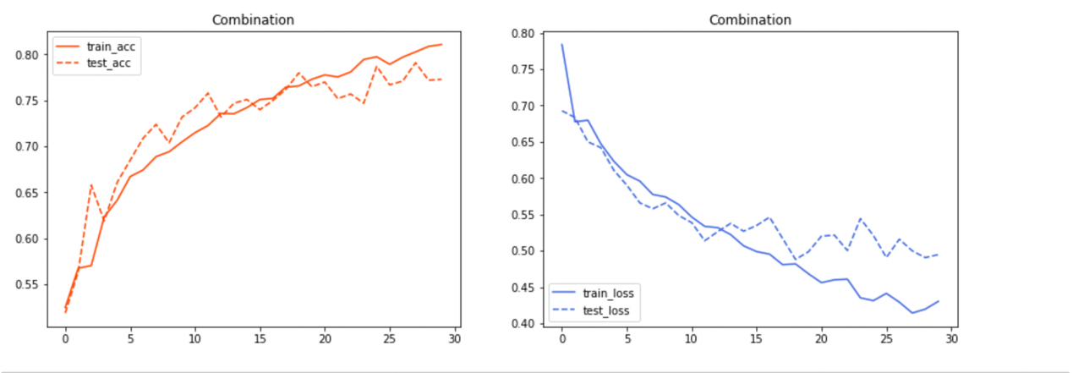

From the record, we can see the model have a good generalization at epoch 21, which training and testing accuracy is close to each other. The test accuracy is around 0.7730 which have a good performance on generalization and accuracy.

ISSUES

Many problems were found in this project. My personal device is Mac M1 OS, pytorch is not suitable for GPU calculation on Mac, so I choose tensorflow frame. The original environment import tensorflow could make the kernel down. So I use miniforge to install the environment for tensorflow. After deploy the environment, the tensorflow augmentation method tensorflow.keras.layers.experimental.preprocessing can not work. It need to downgrade the numpy to version 1.19.5. So I reinstall the numpy 1.19.5, but found cv2 cannot work. So I change the function to read and resize the images by using PIL. The augmentation layers need to use this command to run .

And the model need to run on GPU with this command . Otherwise the code may have error for Mac M1 OS.

CONCLUSION

The projects applied different data augmentation to enhance the performance of image classification problem, some augmentation like flip, rotation, crop, zoom all have some influence on model capacity. The gaussian noise appears to have no significant improvement on this task. Using some combination of augmentation method can improve the model generalization during training.

REFERENCE

<https://www.tensorflow.org/versions>

<https://www.youtube.com/watch?v=JCBe_yjDmY8&list=PLXO45tsB95cKI5AIlf5TxxFPzb-0zeVZ8&index=27>

<https://blog.csdn.net/weixin_43939952/article/details/104037604>